

**Library Management System for Stanford University**

**SIMPLILEARN PC BA - CBAP CERTIFICATION PROJECT – 2**

Submitted By:

**Rohan Maity**

Table of Contents

Introduction 3

Business Analysis Core Concept Model (BACCM) 4

Project Tasks 6

1. Stakeholder Identification 6

1.1 Internal and External Stakeholder Classification 6

1.2 Stakeholder Activity Analysis 6

1.3 Stakeholder Onion 8

1.4 RACI Matrix 8

1.5 Stakeholder Matrix 9

2. Problem Statement Identification 11

3. Advantages of the New Library Management System 12

4. As-Is and Future State Map 13

4.1 As-Is State 13

4.2 Future State 14

5. Case Diagram Scope of the New Library Management System 15

6. Main Features to be developed 16

7. In-Scope and Out-of-Scope Items for the Software 17

8. Data Flow Diagram of the System 18

9. ER Diagram of the System 19

10. Requirements of the Business 20

10.1 Functional Requirements 20

10.2 Non-Functional Requirements 20

11. Mock Screens for the New Library Management System 21

# Introduction

Stanford University is a private research University located in California and was founded in 1885. There are 83 Nobel laureates, 28 Turing Award laureates, and 8 Fields Medallists who are affiliated with Stanford as part of the student body, alumni, faculty, or staff.

In 1885, Stanford started their own library so that they can help the students, and the library was housed in one large room capable of accommodating 100 readers. The size of the library increased as the university grew to enroll more than 20,000+ students in a given year, and currently the library has more than 4 million books in it.

However, the existing management system for the library is a paper based system which maintains, organises, and handles all the books and is a nightmare for the library staff. As such, the university wanted a Library Management Software to automate their library’s management activities for books. With the help of this software, an individual will be able to effectively find books with a click, issue/reissue books quickly, and it will manage all the data efficiently using this system. It also provides immediate and accurate information regarding any type of book, magazine, or research paper, thereby saving a lot of time and efforts.



**Figure 1: Stanford University Logo**

# Business Analysis Core Concept Model (BACCM)

BACCM or Business Analysis Core Concept Model is a conceptual framework for business analysis which evaluates six core concepts of any given business analysis project or task.

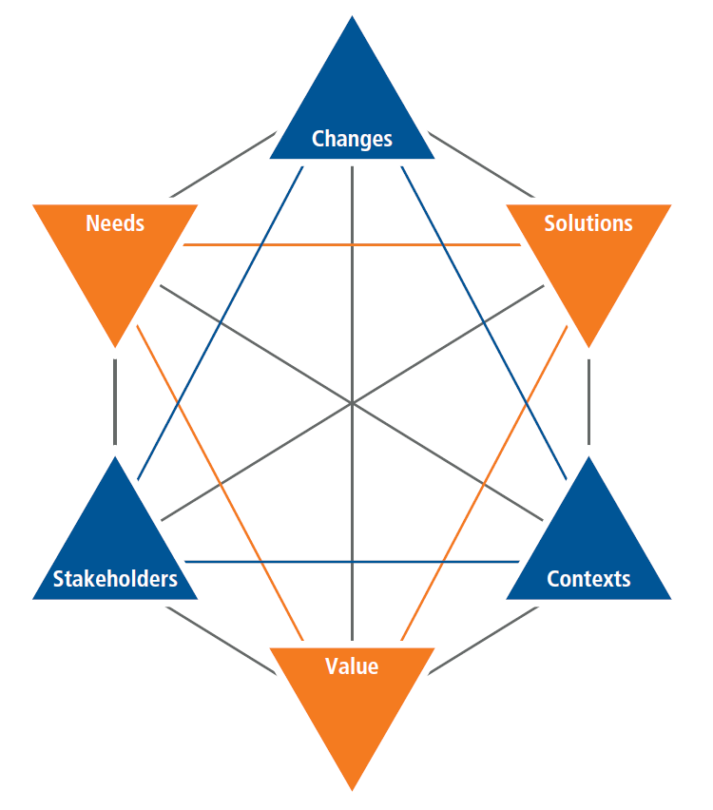

**Figure 2: BACCM Model**

In the context of the problem faced by the Stanford University for their library management system, the application of the BACCM model will yield:

|  |  |
| --- | --- |
| BACCM | |
| Context | The existing management system for the Stanford library is a paper based system which maintains, organises, and handles more than 4 million books in the library and is a nightmare for the library staff. |
| Need | * A lot of time is wasted managing the manual library. * The number of employees needed to manage the library is high. * Fine calculation is a tedious and time-consuming affair. * No reports could be generated on books issued due to the manual system. * It is difficult to manage over 4 million books present in the library. * Students could deposit the books only in the library timings. |
| Change | * Switching from an out-dated paper based library management system to an automated library management software system for the management and organization of over 4 million books. * Finding books with one click, issuing/re-issuing books and management of data in an efficient manner. * Reduction of time and effort for information gathering on books, magazines, and research papers. * Enhancement of student engagement with the library. * Generation of reports on the books. |
| Solution | Development of a Java based library management software system for the management and organization of over 4 million books in the library that will reduce usage of manpower, time, cost, and effort, while enhancing productivity, student engagement, and generation of reports for improved decision-making. |
| Stakeholder | * **Internal Stakeholders:** Domain SME, Implementation SME, Tester, Operational Support, and Project Manager. * **External Stakeholders:** Stanford University Management, Stanford University Students, Library Staff, Books Suppliers, and Payroll Administration. * **Business Analyst** |
| Value | * Reduce overheads and increase productivity of library staff. * Reduction of cost as well as manpower for books management. * Up-to-date records of all books, research papers, magazines, and other materials available in the library. * Improve student engagement in the library. * It will generate dynamic reports for better decision-making. |

**Table 1: BACCM Core Concepts for Stanford University Library Management System**

# Project Tasks

## 1. Stakeholder Identification

### 1.1 Internal and External Stakeholder Classification

The internal and external stakeholders for the new Library Management System for Stanford are:

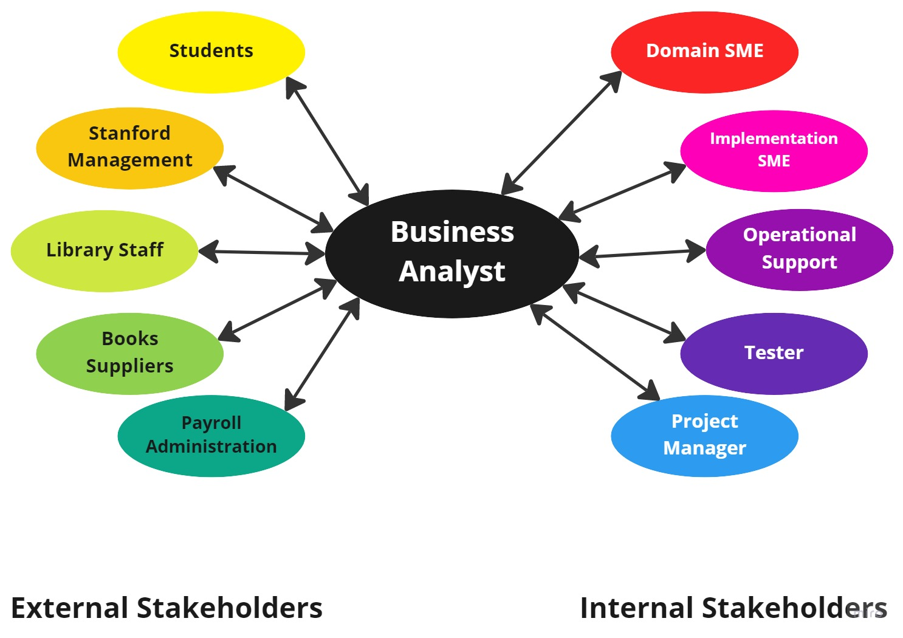

**Figure 3: Stakeholder Classifications**

### 1.2 Stakeholder Activity Analysis

|  |  |
| --- | --- |
| **Actor** | **What they can do on the Software Created** |
| **Students** | * Login and find available books in the library with a single click. * Get immediate summary and other types of accurate information regarding the books, magazines, and research papers in the library. * Issue and Reissue books quickly from the library. * Deposit the books anytime outside the library timings. * Request for specific books, magazines, and research papers in the library. |
| **Stanford Management** | * Assess the dynamic reports generated for better decision-making process. |
| **Library Staff** | * Login and manage availability of books for issue and reissue. * Handle the library data and manage them effectively. * Conduct easy and fast calculation. * Catalogue and arrange over 4 million books in the library. * Send requests for specific books, magazines, and research papers to the suppliers. |
| **Books Suppliers** | * Supply books to the library as per the requests. |
| **Payroll Administration** | * Manage salary of the library staff members. |
| **Business Analyst** | * Engage with the internal and external stakeholders. * Understand the specific project requirements. * Create BA deliverables and essential documents. |
| **Domain SME** | * Provide inputs on the functional developments of the system. |
| **Implementation SME** | * Take inputs from the internal stakeholders and business analyst. * Develop the library management software application system. |
| **Operational Support** | * Provide customer care support for the staff members and students. * Handle user interface (UI) and provide support for backend development requests. |
| **Tester** | * Perform quality analysis on the system for identifying any bugs or issues. * Verify the functionality of the system before its release for usage. |
| **Project Manager** | * Take actions to help guide the project to completion efficiently and effectively. * Guide the internal stakeholders for the development and successful release of the system. |

**Table 2: Stakeholders and their Activities in the Software**

### 1.3 Stakeholder Onion

The Stakeholder Onion is a diagram that helps to highlight the relationship of the stakeholders with the project goals. In the context of the project of the New Library Management System for Stanford University, the Stakeholder Onion will be:

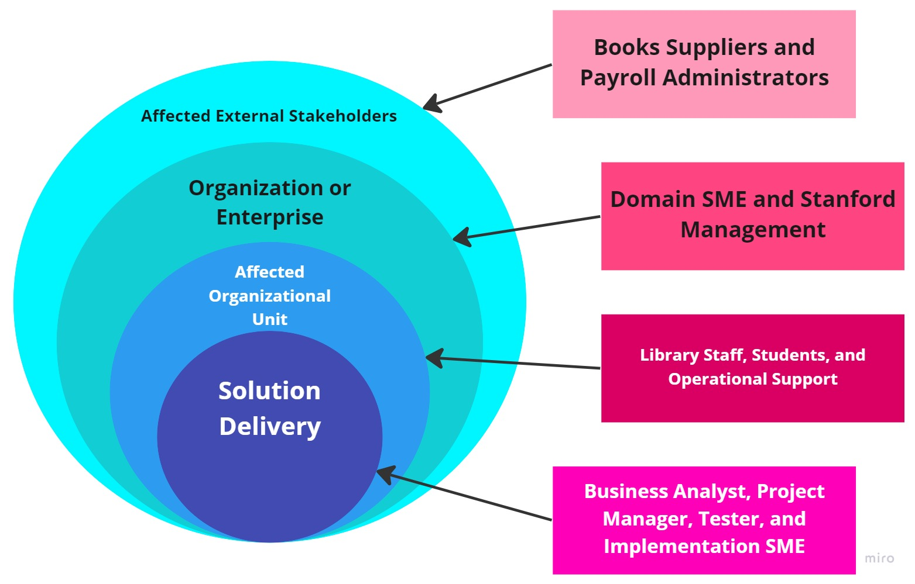

**Figure 4: Stakeholder Onion**

### 1.4 RACI Matrix

The RACI Matrix is a form of stakeholder analysis matrix that categorizes the responsibilities of the stakeholders in a project into 4 different types. These are:

* **Responsible (R):** The stakeholders performing the work on the task.
* **Accountable (A):** The stakeholders held accountable for the successful completion of the task and is the decision-making individual with only one stakeholder being designated this responsibility type.
* **Consulted (C):** The stakeholders who are asked for or consulted regarding inputs, opinions, information, and advice on the tasks and is generally designated to the subject matter experts (SMEs).
* **Informed (I):** The stakeholders who are kept updated or notified of the task and its outcomes where information flows in one way and is different from consulted where information flows two-way.

In the context of the project of the New Library Management System for Stanford University, the RACI Matrix will be:

|  |  |  |  |  |
| --- | --- | --- | --- | --- |
| **Stakeholders** | **Responsible** | **Accountable** | **Consulted** | **Informed** |
| **Students** |  |  |  | **I** |
| **Stanford Management** |  |  |  | **I** |
| **Library Staff** | **R** |  |  | **I** |
| **Books Suppliers** |  |  |  | **I** |
| **Payroll Administration** |  |  |  | **I** |
| **Business Analyst** | **R** |  |  |  |
| **Domain SME** |  |  | **C** |  |
| **Implementation SME** | **R** |  | **C** |  |
| **Operational Support** |  |  | **C** |  |
| **Tester** | **R** |  | **C** | **I** |
| **Project Manager** | **R** | **A** | **C** |  |

**Table 3: RACI Matrix**

### 1.5 Stakeholder Matrix

The stakeholder matrix aids in plotting the relationship between stakeholder influence and stakeholder interest. Based on the axis of influence and impact, the stakeholder matrix is divided into four quadrants and these are:

* **High Influence/High Impact:** It is important to work closely with these stakeholders to win their support and win their agreement to the change.
* **High Influence/Low Impact:** These stakeholders must be involved and heard in order to keep them happy as the change must satisfy their demands.
* **Low Influence/High Impact:** These stakeholders should be consulted for their opinions and kept updated on the change as they support it.
* **Low Influence/Low Impact:** As they don't significantly influence or impact the process, these stakeholders are informed and monitored, but it's important to make sure that their influence doesn't change.

For the project of the New Library Management System for Stanford University, the Stakeholder Matrix will be:

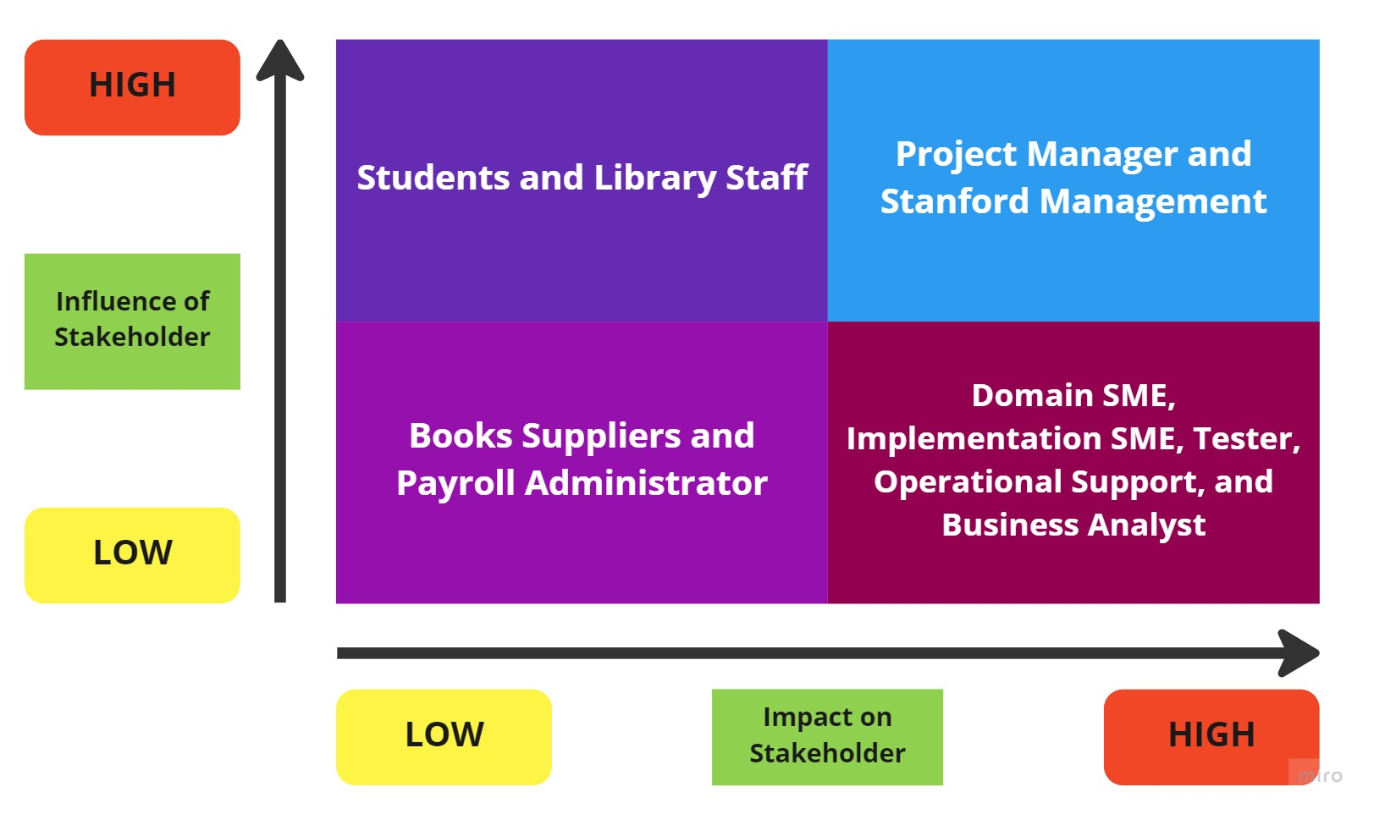

**Figure 5: Stakeholder Matrix**

## 2. Problem Statement Identification

The main given problems in the context of Stanford University are:

* A traditional paper based manual system of management for the library which wastes a lot of time and reduces productivity.
* Due to the presence of over 4 million books in the library, it becomes difficult for the faculty to manage them all.
* Due to the large size of the library and the amount of books, magazines, and research papers it has, a large number of employees are needed for management which incurs excess cost.
* The paper based manual system of management causes fine calculations to become an inefficient, tedious, and time-consuming process.
* Reports on books issued cannot be generated due to the manual system which makes it difficult for Stanford management to take improvement actions.
* Students can only deposit the books only during the library timings, which can be inconvenient for them and thus, it affects their engagement levels.

## 3. Advantages of the New Library Management System

There are several advantages of the new Library Management System and these advantages are:

* Reduction of overheads and costs
* Increased productivity of Library staff
* Updated records of books, research papers, magazines, and other materials available in the library
* Improved student engagement with the library
* Generation of reports for better decision-making process
* Fast and efficient fine calculations can be done easily
* Books can be issued and reissued in a single click

## 4. As-Is and Future State Map

### 4.1 As-Is State

The current existing Library Management System of Stanford can be described using this process flow diagram:

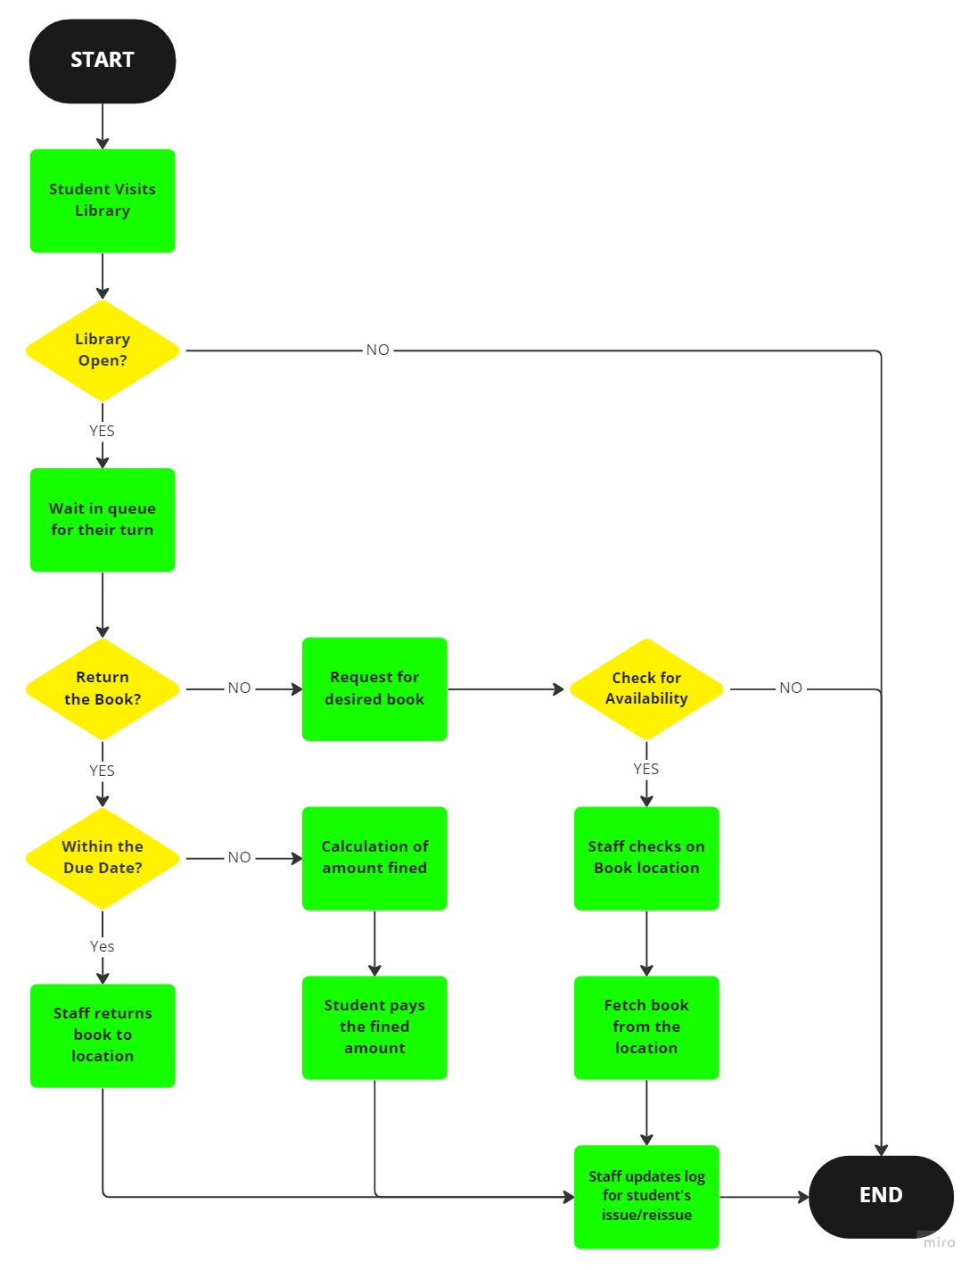

**Figure 6: As-Is State Flow Chart**

### 4.2 Future State

The future state of the Library Management System of Stanford can be described using this process flow diagram:

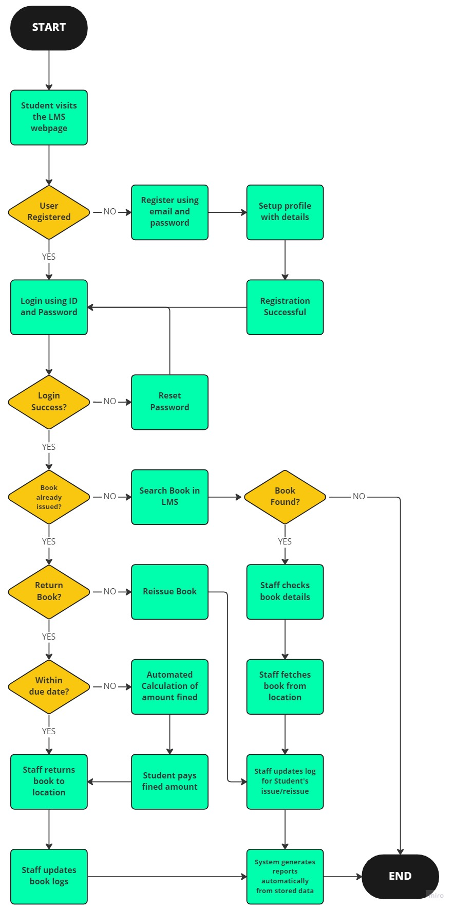

**Figure 7: Future State Flow Chart**

## 5. Case Diagram Scope of the New Library Management System

The scope of the Library Management System of Stanford can be illustrated using the case diagram:

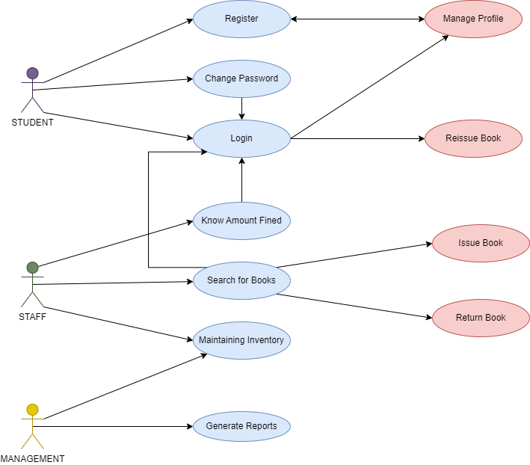

**Figure 8: Case Diagram of LMS**

## 6. Main Features to be developed

The main features to be developed for this proposed new Library Management System or LMS are:

* Students and library staff registration and login in the LMS.
* Students and library staff profile for their books issued/reissued and dues.
* LMS should be able to manage and update the list of books, magazine, research papers, journals, newspaper and other reading materials.
* LMS should be able to appropriately categorize and classify the books, magazine, research papers, journals, newspaper and other reading materials.
* Every reading material should have RFID tag on it and its information will be stored into the database for quick search and summary of the book details.
* Library staff can easily search books and get details of the books through RFID tag when students try to borrow it.
* LMS should be able to record issue and reissue as well as due dates for books.
* LMS should be able to calculate fines for late submissions of books past due date.
* Students should be able to access LMS anytime and check due date for their books as well as fines incurred by them.
* LMS should be able to notify students of due dates and fines starting 3 days before due date as well as post-due dates if books are not returned and this will be done by sending automated notifications on student’s profile and email.
* LMS should be able to maintain the safety and security of the books from theft using the RFID tag on them.
* LMS should be able to manage and share information and data using cloud storage to Stanford Management and Library Staff.
* LMS should be able to generate and manage reports on the books issued and re-issued, fines incurred, lost or damaged items, total number of reading materials, and so on.

## 7. In-Scope and Out-of-Scope Items for the Software

The in-scope and out-of-scope items for the Library Management System software are:

|  |  |
| --- | --- |
| In-Scope | Out-of-Scope |
| 1. Online Website System. | 1. **Reading materials for sale.** |
| 1. Student and Library login and registration. | 1. **Notification for Books Supplier.** |
| 1. Availability status of the reading materials in the Library. | 1. **Access to non-Stanford individuals** |
| 1. Records for books issues, reissues, dues, and fines. | 1. **Library Memberships** |
| 1. Issue, Reissue, and Return books quickly. | 1. **Donations of books and other reading materials** |
| 1. Installation of RFID. | 1. **Library Staff as well as Stanford Students information.** |
| 1. Automated calculation of Fines. | 1. **Payment collection for fines** |
| 1. Storage, Management, and sharing of data in Cloud. | 1. **Generation of RFID** |
| 1. Automatic database maintenance as well as email and notification sending process. |  |
| 1. Generation of reports on books issued and re-issued, fines incurred, lost or damaged items, total number of reading materials, and so on. |  |
| 1. Availability of e-books and e-journals. |  |

**Table 4: In-Scope and Out-of-Scope Items**

## 8. Data Flow Diagram of the System

The data flow diagram of the Library Management System of Stanford will be:

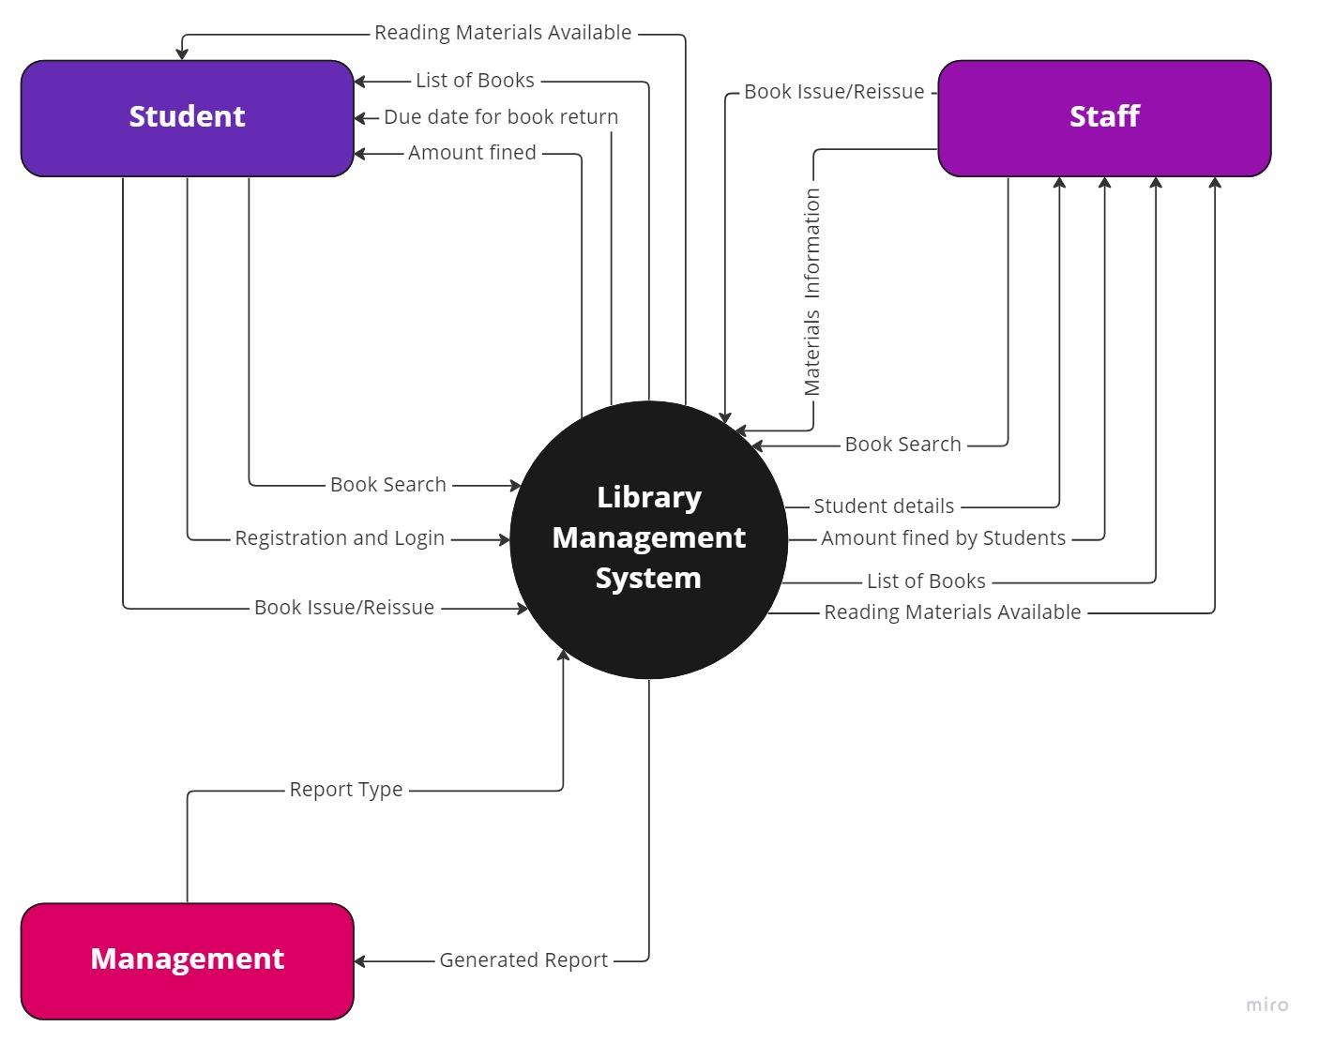

**Figure 9: Data Flow Diagram of LMS**

## 9. ER Diagram of the System

The Entity Relationship or ER Diagram for the system will be:

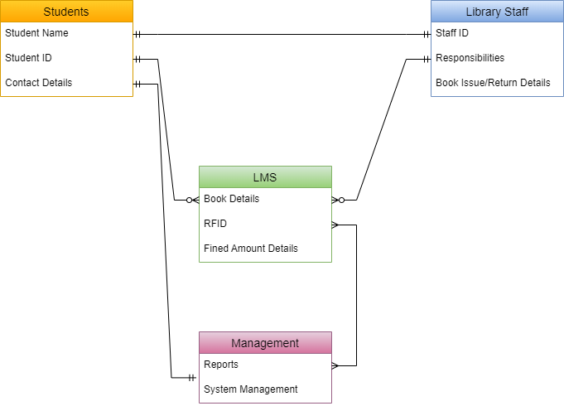

**Figure 10: Entity Relationship Diagram of the System**

## 10. Requirements of the Business

### 10.1 Functional Requirements

The functional requirements for the Library Management System software are:

* Website of the LMS.
* Login and Registration pages along with user dashboard.
* Recording system for different reading materials in the library.
* System for accessing information on reading materials issuing and reissuing, due dates, availability of reading materials, and fines incurred.
* System for calculating fines.
* System for easy searching of information in one click.
* System for automatic mailing and sending notifications.
* System for being used on PCs and phones.
* Installation of RFID anti-theft system for triggering alarm in case of theft.
* Generation of reports on books issued and re-issued, fines incurred, lost or damaged items, total number of reading materials, and so on.

### 10.2 Non-Functional Requirements

The non-functional requirements for the Library Management System software are:

* Availability: Webpages should be available 24x7 to everyone.
* Usability: User-Friendly interface and easy to navigate and use.
* Scalability: Software system can easily allow more than 20,000 individuals logged in at any given time and support data of over 4 million books.
* Maintainability: Software should be coded in Java and thus, requires little maintenance.
* Reliability: Software should concise and highly accurate in its searches and information.
* Functionality: Software should be highly efficient and precise.
* Portability: Software should be designed to function in Windows, MacOS, Android, and iOS operating systems.
* Security: Software should be highly secured to protect login credentials and user information.

## 11. Mock Screens for the New Library Management System



**Figure 11: Stanford LMS Website Login Page**

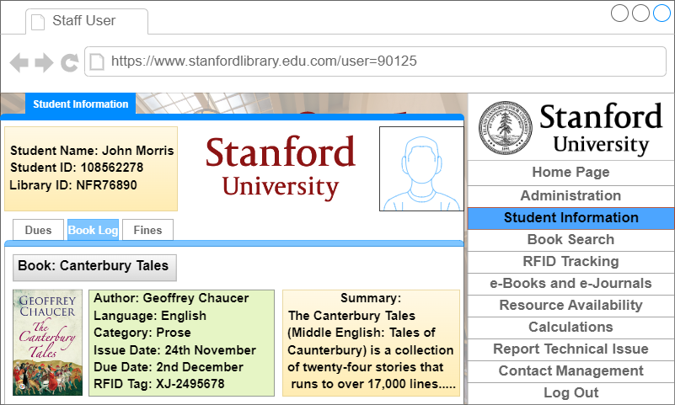

**Figure 12: Stanford LMS Student’s Book Log Viewer**